BÀI TẬP CHƯƠNG 6&7
STRING VÀ FILES
PHẦN 1: LƯU ĐỒ GIẢI THUẬT CỦA CHƯƠNG 6 & 7
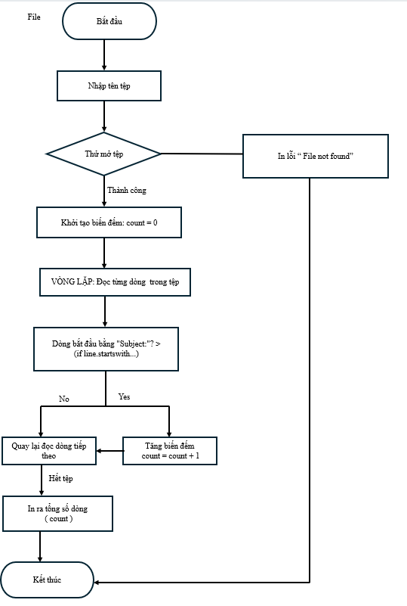
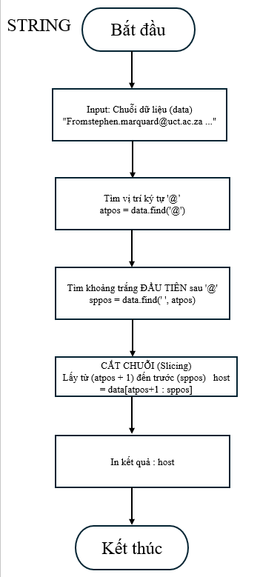

PHẦN 2: BÀI TẬP CHƯƠNG 6 & 7
CHƯƠNG 6
Exercise 5: Take the following Python code that stores a string:
‘ str = ’X-DSPAM-Confidence:0.8475’
Use find and string slicing to extract the portion of the string after the colon character and then use the float function to convert the extracted string into a f loating point number.

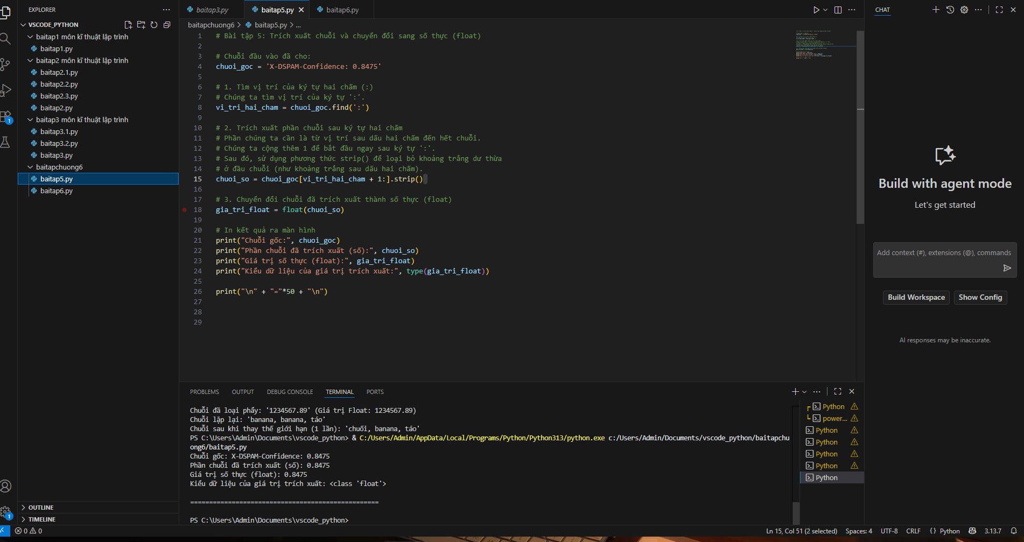
Exercise 6: Read the documentation of the string methods at https://docs.python.org/3.5/library/stdtypes.html#string-methods You might want to experiment with some of them to make sure you understand how they work. strip and replace are particularly useful. The documentation uses a syntax that might be confusing. For example, in find(sub[, start[, end]]), the brackets indicate optional arguments. So sub is required, but start is optional, and if you include start, then end is optional.
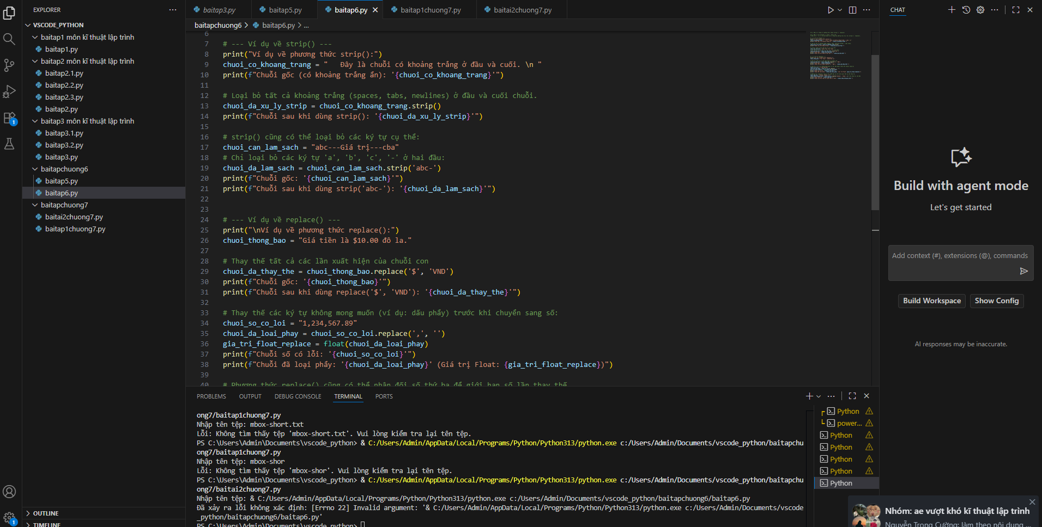

CHƯƠNG 7
Exercise 1: Write a program to read through a file and print the contents of the f ile (line by line) all in upper case. Executing the program will look as follows:
python shout.py
Enter a file name: mbox-short.txt
FROM STEPHEN.MARQUARD@UCT.AC.ZA SAT JAN 5 09:14:16 2008
RETURN-PATH: <postmaster@collab.sakaiproject.org>
RECEIVED: FROM MURDER (MAIL.UMICH.EDU [141.211.14.90])
BY FRANKENSTEIN.MAIL.UMICH.EDU (CYRUS V2.3.8) WITH LMTPA; SAT, 05 JAN 2008 09:14:16-0500
You can download the file from
www.py4e.com/code3/mbox-short.txt
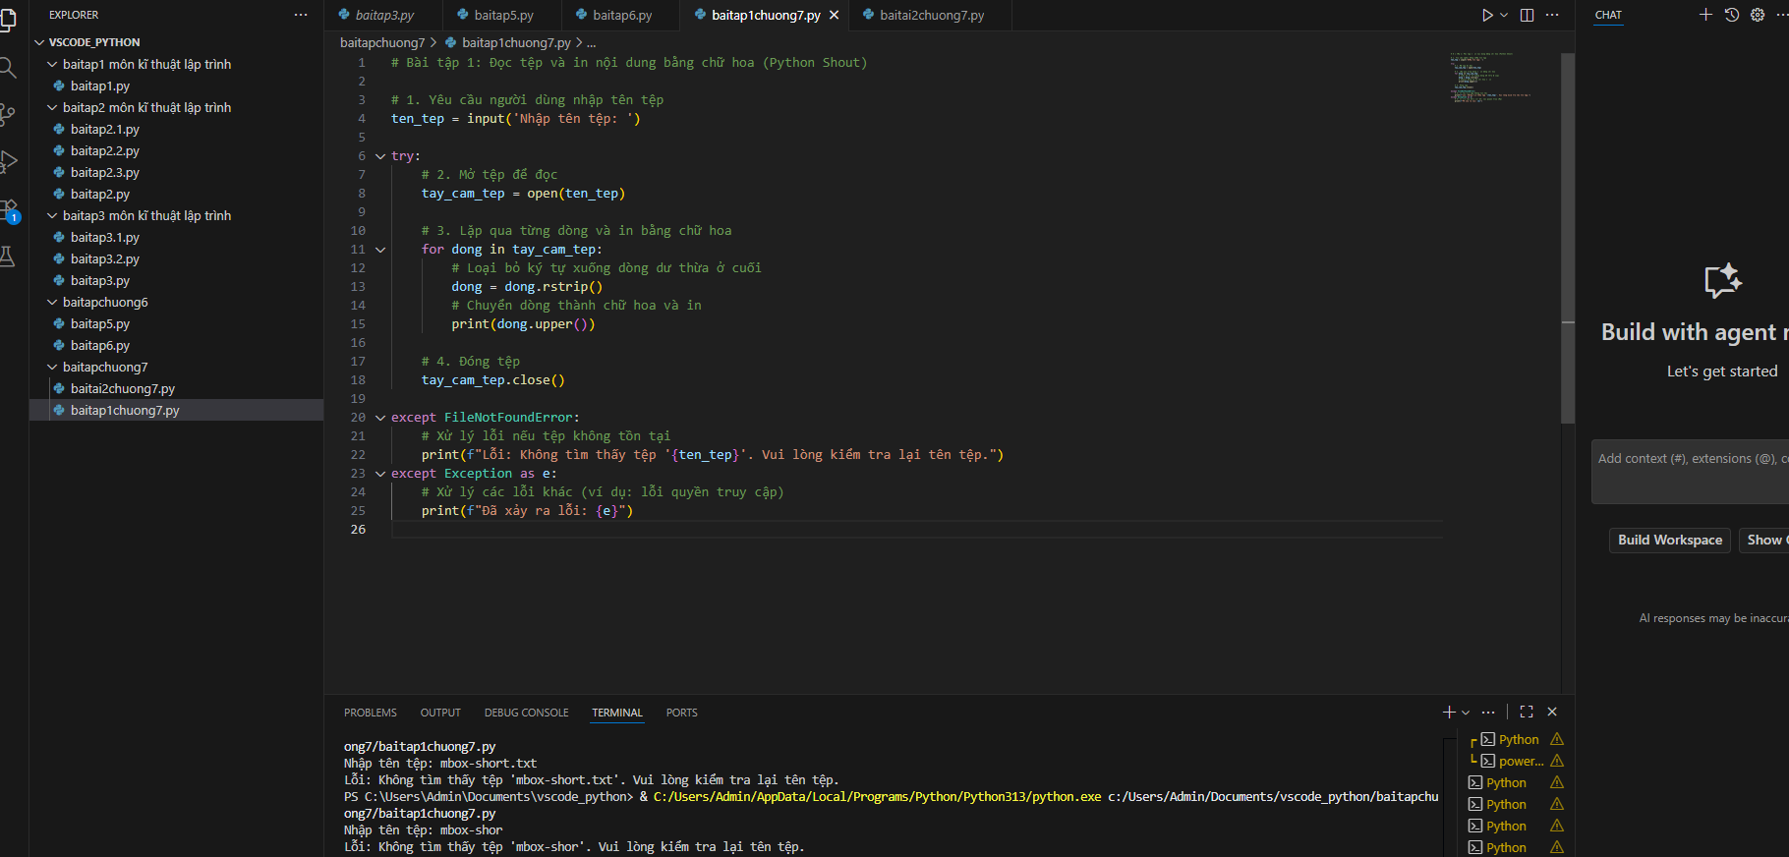

Exercise 2: Write a program to prompt for a file name, and then read through the f ile and look for lines of the form:
X-DSPAM-Confidence:0.8475
When you encounter a line that starts with “X-DSPAM-Confidence:” pull apart the line to extract the floating-point number on the line. Count these lines and then compute the total of the spam confidence values from these lines. When you reach the end of the file, print out the average spam confidence.
Enter the file name: mbox.txt
Average spam confidence: 0.894128046745
Enter the file name: mbox-short.txt
Average spam confidence: 0.750718518519
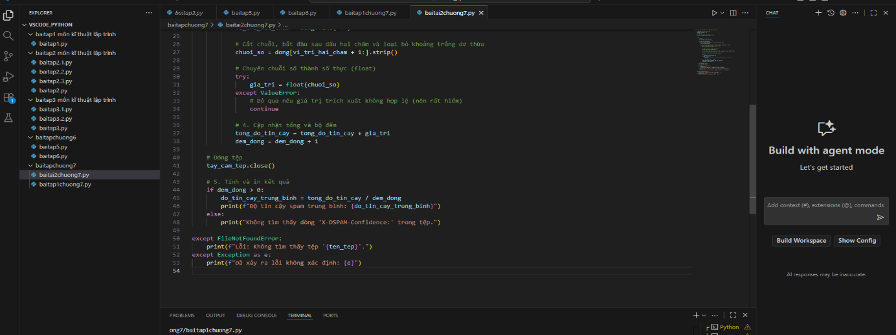
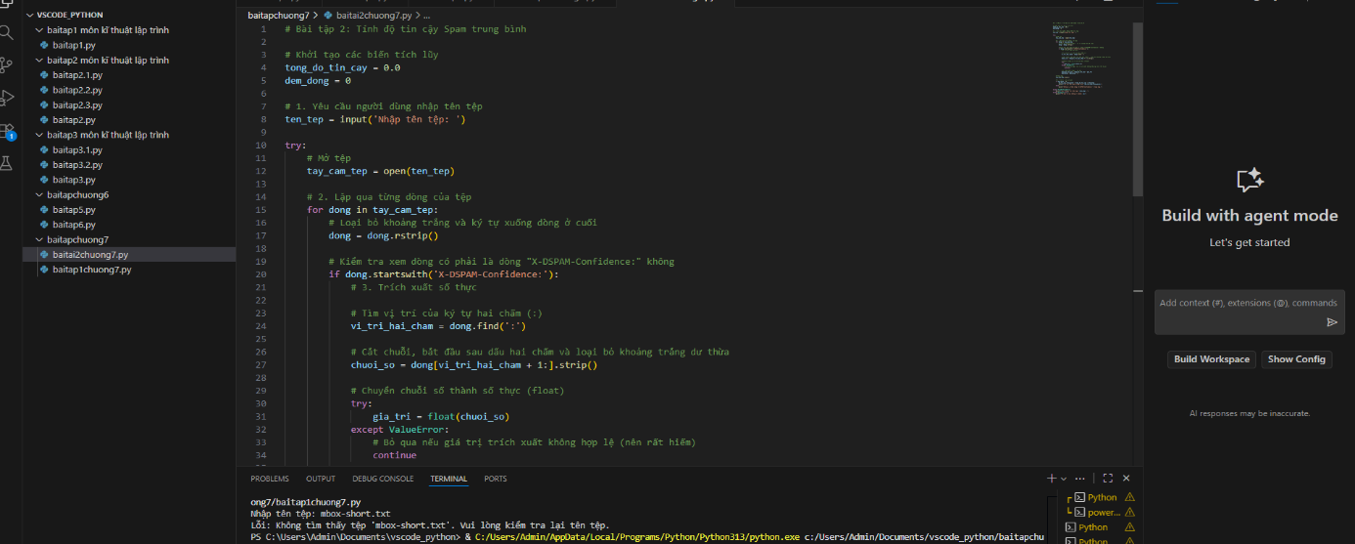
Test your file on the mbox.txt and mbox-short.txt files
Exercise 3: Sometimes when programmers get bored or want to have a bit of fun, they add a harmless Easter Egg to their program Modify the program that prompts the user for the file name so that it prints a funny message when the user types in the exact file name “na na boo boo”. The program should behave normally for all other files which exist and don’t exist. Here is a sample execution of the program:
python egg.py
Enter the file name: mbox.txt
There were 1797 subject lines in mbox.txt
python egg.py
Enter the file name: missing.tyxt
File cannot be opened: missing.tyxt
python egg.py
Enter the file name: na na boo boo NA NA BOO BOO TO YOU- You have been punkd!
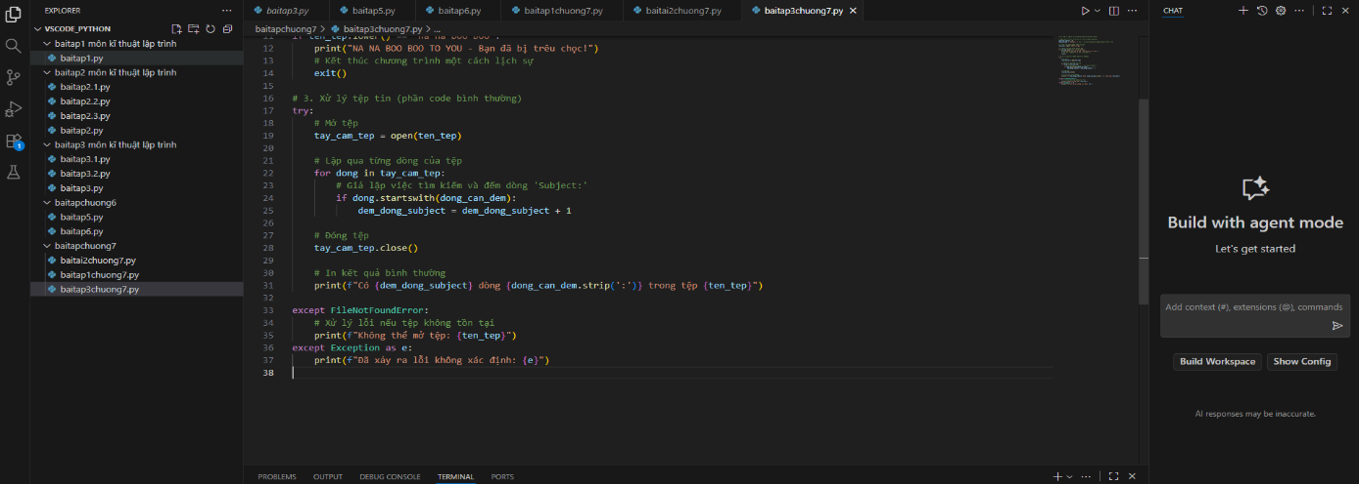
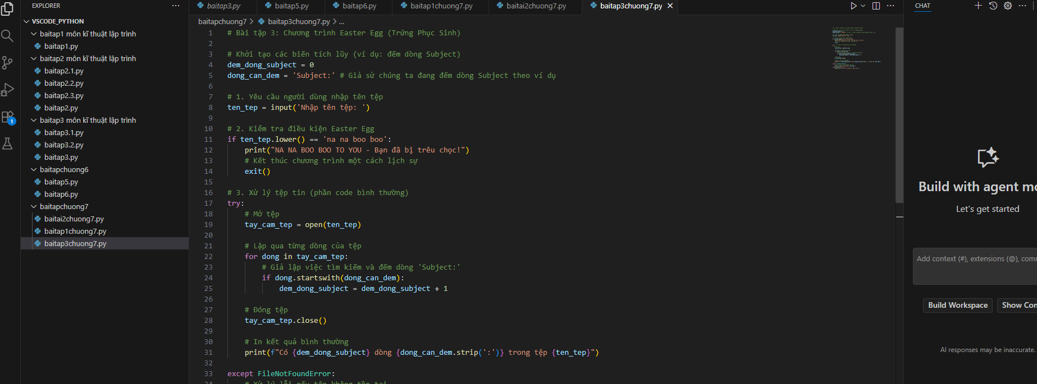
We are not encouraging you to put Easter Eggs in your programs; this is just an exercise

